The Green Gram Community Refill Shop
Fire Safety Policy

Introduction
This is the Fire Safety Policy of The Green Gram Community Refill Shop (“The Green Gram”). Fire safety falls within the scope of the Health and Safety Policy, and as such this document should be read in conjunction with the Health & Safety Policy and Safeguarding & Lone Working Policy.
The Green Gram recognises the obligation it has to its volunteers and customers under the Regulatory Reform (Fire Safety) Order 2005 (The Order). This places a legal responsibility on those who are best placed to address fire safety and ensure that risks - which necessarily change over time - are kept under review. Under The Order a 'Responsible Person' (usually the owner, landlord, employer, or occupier of a business or industrial premises) must carry out a fire risk assessment. Responsible persons under the Order are then required, following a risk assessment, to implement appropriate fire safety measures to minimise the risk to life from fire; and to keep the risk assessment up to date.
Where a building has multiple occupiers, there may be more than one Responsible Person with regard to the The Order. Where this is the case, there is a legal requirement for Responsible Persons to work together to discharge the duties set out in The Order.
In the case of The Green Gram, the Responsible Person designation is shared with the both the Management Committee, delegated to the Business Manager, and the Landlord of the building (Daniel & Hannah Baggott). An additional consideration for fire safety is the mixed occupancy, ie residential units adjacent to and above the shop premises within the same building.

- Statement of intent
The Green Gram will comply with all aspects of relevant legislation. Under The Order, The Green Gram must:
- Carry out a fire risk assessment of the workplace, taking into consideration volunteers, customers and all other people who may be affected by a fire in the shop such as delivery drivers and contractors and make adequate provision for any volunteers and customers with additional needs who use, or may be present in the premises;
- Identify the significant findings of the risk assessment and the details of anyone who might be especially at risk in case of fire and keep a written record of these risk assessments and mitigation plans;
- Provide and maintain such fire precautions as are necessary to safeguard those who use the workplace;
- Provide information, instruction and training to volunteers about the fire precautions in the workplace, including what to do in the event of a fire and safe evacuation routes.

- Responsibility
Overall and final responsibility for fire safety for all volunteers and users within the shop lies with the Management Committee but will be delegated to the Business Manager. The Business Manager will be responsible for ensuring that this policy is upheld and report back to the Management committee.

- The Responsible Person is noted on fire risk assessments. All volunteers will be made aware of who is responsible for Fire safety.
- All volunteers have a duty to:
    - familiarise themselves with this policy and co-operate with the committee on fire safety matters;
    - participate in fire safety training, including fire drills/evacuation practice;
    - not interfere with anything provided to assist with fire safety, for example fire extinguishers and smoke alarms;
    - take reasonable care to ensure fire escapes routes are kept clear and are easily accessible;
    - ensure electrical equipment is switched off and left in a safe condition after use to minimise fire risk when the shop is unoccupied;
    - report incidents, hazards or concerns relating to fire safety to the Business Manager or, if the Business Manager is unavailable, a committee member.

- General Fire safety arrangements
Equipment
- Fire Extinguishers
The Green Gram has two sets of double fire extinguishers. These are located by the hand washing basin in the serving area, and at the back of the shop in the stock area. Each comprises a C02 extinguisher colour-coded black for use on flammable liquids and live electrical fires, and a foam extinguisher colour coded cream/white for use on wood, paper and textiles, and flammable liquids and are labelled as such. The pressure valves on the fire extinguishers are checked monthly and this is recorded in the fire safety log kept in the filing cabinet. They are serviced annually by Fireguard Services Ltd.

- Smoke Alarms
The Green Gram has two smoke alarms fitted in the shop. These are tested monthly and recorded in the fire safety log.

- Red Box Break Glass Fire Alarm
The Green Gram has a Red Box Break Glass Fire Alarm system fitted. There are two Red Box Break Glass boxes. One in the retail area by the front door on the right as you enter the shop, and one in the stock area at the very back of the shop to the right-hand side of the fire exit. When there is a visible green light flashing that means the system is working. The fire alarm system is maintained by the Landlord so we are unable to test the system: he will test on an annual basis.
The Lead Volunteer will be responsible for checking that the Red Box Break Glass Fire Alarm system is working by checking that the flashing light is visible when undertaking the “opening the shop” tasks.

In the event this is found to be inoperable, the Business Manager should be informed, who will then contact the Landlord, as the break glass fire alarm also services residential flats within the building. Volunteers should be informed to be extra vigilant. The shop premises is single storey and open plan, alerting one another to the presence of fire would be achievable with a loud shout in the event of fire alarm failure. In addition, the smoke alarms would activate.

- Emergency lighting
There is emergency lighting in the shop that remains on in the retail, stock and WC area and motion activated emergency lighting in the corridor leading to the fire escapes.

- Telephones
There are two telephones located within the shop, one at the front of the shop on the shelves in the customer area housing the non-food products, and one at the back of the shop on the far the righthand side of the double sink.

- Assembly Point
Assemble outside Belinda’s (directly opposite The Green Gram).

- Evacuation Routes
There are three ways to evacuate the shop:
- Exit through the front door, cross the road at a safe place (use the zebra crossing to the left of the shop opposite Co-op to cross the road where possible);

- Exit through the fire exit at the rear of the shop by pushing the bar, turn right and open the latched door by turning the latch handle downward and pulling the door towards you to open it and gain exit on to the High Street. Cross the road at a safe place (use the zebra crossing the left of the shop opposite Co-op to cross the road where possible);

- Exit through the fire exit at the rear of the shop by pushing the bar, turn left and go down 3 steps. Push bar to open second fire door, and follow path until you come to a wooden gate. Open the bolt, turn the latch and push the gate open. Immediately turn left, and cross a patch of grass, tun left and left again to come up to the High Street. Cross the road at a safe place (use the zebra crossing to the left of the shop opposite Co-op to cross the road where possible).

Evacuation routes will be checked daily to ensure they are clear and accessible and to ensure other occupants of the building have not placed items such as wheelie bins in a hazardous manner.

- Procedure on discovering a fire or suspicion of fire
Upon discovering a fire or signs of fire, volunteers should immediately alert the Lead Volunteer who should ensure the following actions are taken
- Break the glass on the nearest Red Box Break Glass Fire Alarm
- Call 999 and summon the fire brigade
- Direct volunteers and customers to exit the building via the safest route
- Provide assistance to any volunteer or customer needing additional help to exit
- Check the recycling area and toilet area to ensure no-one remains inside
No volunteer should attempt to tackle a fire themselves unless it considered safe to do so and have appropriate knowledge of how to use the fire extinguishers.
Volunteers should assemble outside Belinda’s, directly across the road from The Green Gram, taking care when crossing the road, and using the zebra crossing where possible.

- Training
All volunteers will be provided with fire safety training at induction, which will include:
- Overview of fire safety equipment
- Responsibilities in keeping fire escape routes clear and reporting any issues noted
- What to do in the event of a fire
- Safe evacuation routes, including practice use of these routes.
- Refresher training will be delivered annually

- Review and revision
The risk assessment and policy will be reviewed annually, or in the event of any of the following, whichever occurs first
- Any significant change of work practices
- Any significant change in staffing levels
- Any structural or material alteration to the premises
- Any near miss or fire

Appendix 1
Fire Risk Assessment
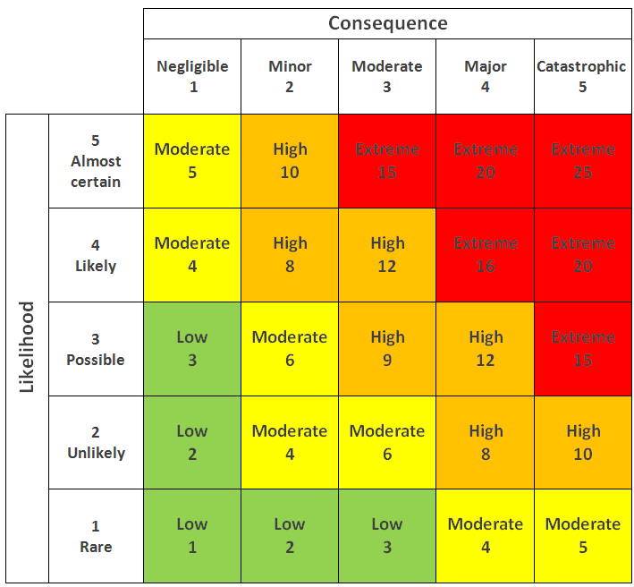
 | Hazard | Who is Affected | Risk Rating | Mitigation | Revised Risk Rating | Other Controls Needed | Deadline for Action | Completed
1. | Fuel - flammable substances on site: paints, thinners etc | Staff, volunteers and customers | 8 | Store in lobby near WC, away from heat sources | 4 |  | End April 25 | Yes
2. | Fuel - combustible material storage: cardboard, paper etc | Staff, volunteers and customers | 8 | Store in lobby near WC, away from heat sources | 4 |  | End April 25 | Yes
3. | Fuel - combustible seasonal decorations | Staff, volunteers and customers | 8 | Do not use plug-in decorations. Locate away from plugs and heaters. | 4 |  | End June 25 | Yes
4. | Fuel - sources of oxygen: percarbonate of soda (green bleach) | Staff, volunteers and customers | 12 | No more than 25kg onsite at once, split between retail container and sack to minimise quantity in one place. | 4 |  | End April 25 | Yes
5. | Ignition - heating appliances: plug-in radiator and wall heaters | Staff, volunteers and customers | 16 | Switch off heaters included in ‘leaving for the day’ procedure. Check periodically whether items near the wall heaters are growing too hot. | 8 |  | End April 25 | Yes
6. | Ignition - smoking | Staff, volunteers and customers | 4 | No smoking allowed on the premises | 4 |  | End April 25 | Yes
7. | Ignition - electrical equipment | Staff, volunteers and customers | 8 | PAT testing schedule in place for electrical equipment. Switch off electricals except till 3 card reader, fridge, coffee grinder and dehumidifier before closing the shop. | 4 |  | End April 25 | Yes
8. | Ignition - extension leads | Staff, volunteers, customers | 8 | Uncoil long extension leads. Do not plug one extension into another. | 4 |  | End April 25 | Yes
9. | People - lone working | Staff and volunteers | 6 | Remove keys from front door lock if alone in the shop, so others can access if needed. | 3 |  | End April 25 | Yes
10. | People - disabilities | Staff, volunteers and customers | 12 | Lead and volunteers to ensure all persons with limited mobility/vision etc are evacuated in case of fire. | 4 |  | End April 25 | Yes
11. | People - escape routes | Staff, volunteers and customers | 12 | Lead and volunteers to guide all present out through the main front door or rear fire exit. Exit to street or garden depending on the route of least risk. | 4 |  | End May 24 | Yes
12. | Escape - routes | Staff, volunteers and customers | 12 | Ensure walkway to rear exit is kept free of clutter and stock. | 4 |  | End May 24 | Yes
13. | Fire Fighting & Detection | Staff and volunteers | 12 | Fire extinguishers and smoke detectors in the retail and stock areas to be checked on a monthly basis. Volunteers advised to evacuate and raise the alarm rather than risk fighting the fire. | 4 |  | End May 24 | Yes

Fire safety training to be provided to each volunteer as part of the induction process. Refresher training and fire drill to be carried out annually in October.

Date Reviewed To be reviewed at any change OR every year. | Signature | Role
14th November 2025 | 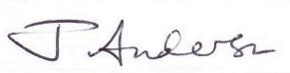 | Shop Manager

